The Jubilee Center for Excellence in Education (JCEE) was founded in 1998, to enhance national and regional standards for education by utilizing advanced educational technology and state-of-the-art testing tools.

**PIONEERING TECHNOLOGY IN EDUCATION The JCEE Model**

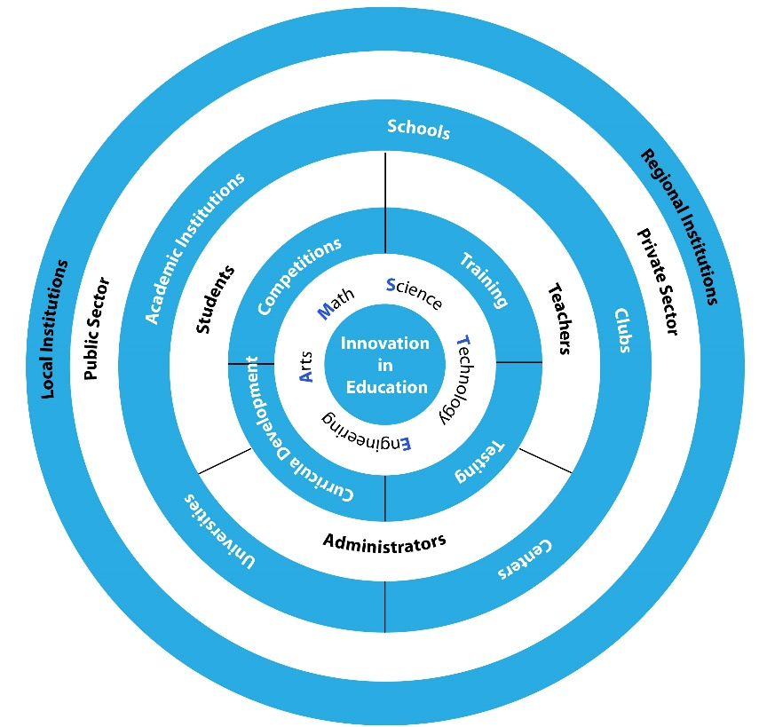The Jubilee Center for Excellence in Education has pioneered Robotics and introduced several STEAM programs within schools and local communities.

Today, thousands of students and teachers throughout Jordan and 11 Arab countries have been trained by the JCCE mobile expert teams. Students, particularly those from marginalized populations, are transformed from test-takers to avid learners as lessons are turned to practical applications by connecting science and technology to daily life. Teachers acquire skills to enhance self-learning by teamwork, analytical skills and research proficiency.

**NATIONAL AND GLOBAL COMPETITIONS**

**JCEE in Numbers - 2019**

* **5160** Students and Teachers
  + **3527** Students
  + **937** Teachers
* **15** National and Regional Competitions Organized
* **76** STEAM Training of Trainers graduated
* **399** Teachers trained
* **696** DAFI scholarships for refugees awarded (61% females)
* **180** DAFI students graduated from **20** Jordanian Universities

JCEE trains local and regional teams to participate in global STEAM competitions such as the Formula One (F1) in Schoolscompetition. For the last 15 years, the center has also been organizing numerous annual national and regional competitions such as the National Robotics Competition, FIRST Lego League, and the Arab Open Robotics Championship. All of these activities and events promote students’ creative problem-solving skills by finding solutions to challenges faced within their communities, countries and the world at large, such as climate change, renewable energy, food production and physical impediments.

**Albert Einstein German Academic Refugee Initiative Fund (DAFI)**

The JCCE since 2009, has extend its work to embrace aspiring youth who are seeking haven in our country, Jordan. In partnership with the UNHCR, young refugees from Syria, Iraqi, Yemen and Sudan are granted scholarships at Jordanian universities along with well-being and life skills support programs. The young scholars are being provided with the opportunity to lead fulfilled and dignified lives whether in their host communities or in their country of origin.

**The King Hussein Science Garden**

Established in 2003, the garden was a pioneering national project, built to bring science and technology to the forefront of education. Annually, the garden provides thousands of students from public and private schools with ‘learning–through–play’ and hands-on experiments. Many basic scientific and technological principles, laws and phenomena are explored or simulated in zones, including force and motion, meteorology, solar energy and astronomy, along with the engineering and electronics labs. Virtual reality, nuclear and photography labs will soon be opened.

A King Hussein Foundation Education Institution

Email: jcee@jubilee.edu.jo Phone: [+962 6 5238216](tel:+96265238216) Facebook:@JubileeCenterForExcellenceInEducation Twitter: [@JCEE_KHF](https://twitter.com/jcee_khf)

Website: <http://www.jcee.edu.jo/>