STEAM KITS

To ensure quality performance, JCEE developed customized STEAM training kits to support its various training programs. The STEAM Kits are specifically designed with different types of beneficiaries in mind. The kits will help build skills in robotics, computer science, engineering, art, programming, creativity, math, problem-solving, and more.
Each type of kit offers unique skills and activities to students and teachers. The kits can be integrated into classes and used in many different subjects, helping students and teachers broaden their understanding of JCEE training programs and work together to complete fun challenges using the highly developed technology. Each kit includes a user manual and training guide.
TYPE OF STEAM KITS

The primary purpose of creating these kits is to link theoretical concepts with practical applications that simulate reality; this allows the training and material to be exciting and appealing to participants. Furthermore, this enables the participants to learn how to deliver training to others comfortably and in an organized manner
- School Students
- V. STEAM
- Artificial Intelligence
- Smart Girls
- Innovation Kit 1
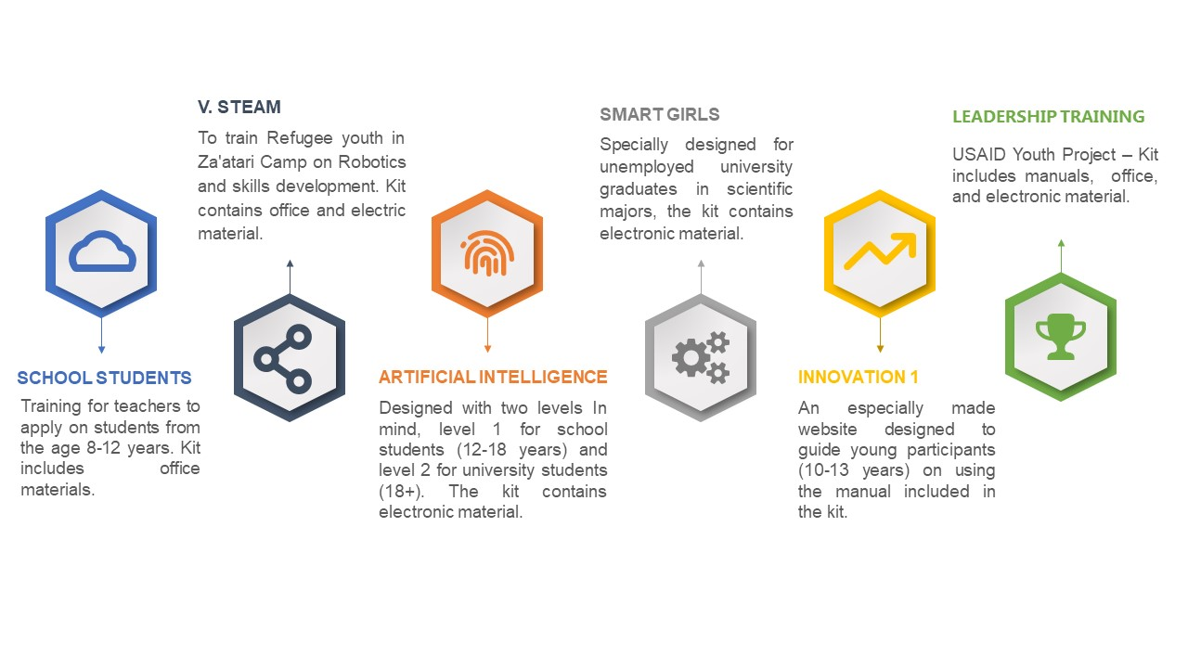
- Leadership Training Package
Figure 1 illustrates the purpose of each kit
.

STEAM KIT DETAILS

# | KIT | Items | Description and Age Group | No. Of Kits | Implemented Programs
1 | School Students | Office materials such as; paper, models, colors, balloons, wooden sticks, scissors, pens, rubber, etc. | Training for teachers to apply on students from the age 8-12 years. | 20 | Preparing a STEAM Teacher- 2020
2 | SMART GIRLS | Electronic materials | Specially designed for unemployed university graduates in science majors. | 44 | SMART GIRLS
3 | V. STEAM | Office, electronic, and informative materials | A Collaboration between Blumont International and the Jubilee Institute to train Refugee youth in Za'atari Camp on Robotics and developing skills. | 55 | Blumont Project (Za’atri Camp)
4 | Artificial Intelligence | Electronic materials | Designed with two levels in mind, level 1 for school students (12-18 years) and level 2 for university students (18+). | Pending | Pending
5 | Innovation Kit 1 | Electronic materials and access to the website designed especially for this kit | An especially made website designed to guide young participants (10-13 years) on using the manual included in the kit. | 1 | Pending
6 | Leadership Training Kit | Office, electronic, and manual | USAID Youth Project – Kit includes manuals, office, and electronic material. | 75 | Pending

